PickupSports
ECE 49595 - Section 063
Fall ry2026

Donovan Baran | barand@purdue.edu
Pranav Balaji | balaji75@purdue.edu
Soham Pandey | pande136@purdue.edu
Ashton Reece | reece12@purdue.edu

Problem Description
Pickup basketball is a regular part of campus life at Purdue, both at the CoRec and on outdoor courts, but it is completely unrecorded. When a run ends there is no score sheet, no stats, and no film. Purdue does support organized play: intramural sports run through IMLeagues with set registration periods and require a paid intramural pass ($55 per year or $30 per semester) [1], sport clubs have tryouts and dues, and many runs organized by clubs, Greek houses, or friend groups are members-only. None of these cover the open, drop-in games where much of casual play happens, and none of them give a player individual performance data from those games. The core problem is that pickup players have no record of how they actually play. Without that record, there is no reliable way for anyone, the player or the people they play with, to know their level.

This affects a large group of players. U.S. team sports participation passed 90 million in 2025, the first time SFIA has recorded that level [2], and students who take part in open recreation and intramurals show higher resilience and sense of belonging than those who do not [3]. Players who want to improve have few options. Phone-based basketball tools like HomeCourt are built around individual training, using interactive drills and shot tracking [4], not live games against other people. Products that capture full games are sold to organized teams. For example, the Veo camera costs $999 and needs a subscription per camera, with plans priced per team [5]. That doesn’t fit a group of students who meet at a court with no coach or team account. The games where students actually spend their time leave nothing behind to learn from.

The lack of a record also creates a trust problem. Because no one’s skill or reliability can be checked, many runs stay private on purpose: you get in by knowing someone who can vouch for you, and skill labels in group chats or apps are self-reported and often wrong. This problem doesn’t depend on scale. A single eight-person run at the CoRec has it, whether the group is open or invite-only. Our goal is not to force private groups open. It is to give organizers real information for deciding who to invite, and to give players a way to build a verified history by playing. What a student cannot do today is set one phone down at a court, play a normal pickup game, and come away with their own stats, shot chart, and highlights, tied to a profile the next group they play with can actually trust.

Solution Description
Overview:
PickupSports is an iOS app, built with React Native, that turns a phone recording of a pickup basketball game into per-player stats and highlights. It then uses that verified game history to help players find the right games and help organizers decide who to let in.
Before a game, the organizer creates it in the app, picks a court, and marks it as recorded. One player mounts their phone on a tripod or fence clip near the baseline and follows a short setup screen. During the game the phone just records. Afterward, the video uploads and is processed on our server. Within about 30 minutes, every tagged player gets a box score (shot attempts, makes, points, and two and three point splits), a shot chart, and clips of their made shots. Over time these games build a basketball profile and rating based on real games instead of self-reported skill.
This version supports half-court games (one hoop, up to 5 on 5), which are common for 3 on 3 and 4 on 4 runs. Full-court recording with two phones is a stretch goal. Game coordination (finding, creating, and joining games) works for basketball, flag football, and pickleball, but video analysis is basketball only.

Video Analysis Pipeline:
- Court calibration: During setup, the app finds the rim and asks the user to confirm a few court points, such as the baseline corners and free throw line. From these we compute a mapping (homography) from the camera image to a flat court diagram. Calibrations from earlier games at the same court are stored and reused to speed up setup.
- Detection: A YOLO-based detector, fine-tuned on footage we label ourselves, finds players, the ball, and the rim in each frame.
- Player tracking: A tracker links detections across frames. Because processing happens after the game, we can use the whole video at once and stitch broken tracks back together with appearance features (shirt color, build, shoes) when players are hidden behind each other.
- Teams and identity: Players are split into teams by clothing color, declared at game start (for example, shirts vs. skins). We do not use facial recognition. After processing, each player sees one thumbnail per detected person and taps the one that is them. Corrections update every stat from that game.
- Shot events: The ball’s path is fit to an arc to detect shot attempts. The shooter is the player holding the ball at release. The shot location is that player’s foot position mapped onto the court diagram. A make is a ball that passes down through the rim area. Events below a confidence threshold are flagged for players to confirm instead of being counted silently.
- Outputs: Per-player box scores, the team score (using the organizer’s scoring rule, such as 1s and 2s or 2s and 3s), shot charts, and a highlight clip of each made shot.
Videos upload in resumable chunks to cloud storage (Wi-Fi by default). A job queue hands each video to a GPU worker, and results are written back to PostgreSQL.

Game Coordination and Trust:
- Courts and map: The map shows our own data on top of Google Maps. We keep a table of courts in PostGIS, seeded by the team with Purdue and West Lafayette courts and their layouts, and the app shows them as pins. Users can submit a missing court, which goes to a review queue before it appears. Every game is tied to a court.
- Visibility modes: Organizers choose Public (anyone in the skill range can join), Request to join (the organizer approves each player and can check their recorded history first), or Private (invite link only, never shown on the map). Private mode lets clubs, Greek houses, and friend groups run their own games through the app without opening them up. Organizers can remove a player and block them from future games.
- Who sees which games: Players only see Public and Request to join games whose skill range includes their rating, so a high-level game is hidden from newer players. New players start with a provisional rating from a short self-assessment and see “all levels” games plus games in their provisional range until they have three recorded games.
- Reliability: Players check in through the app when they arrive (location-based check-in during a window around start time). No-shows and late cancellations lower a reliability score. Creating public games requires a minimum score, so organizers who keep canceling lose that ability until their score recovers. Anyone can still create private games.
- Ratings and recommendations: A player’s basketball rating updates after recorded games, based on the game result and their verified stats, with each stat weighted by the model’s confidence. Recommendations rank visible games by rating fit, distance, and start time, and the app can suggest even teams from a roster’s ratings. These parts use standard methods and are not where we claim complexity.

Privacy and Consent:
Recording is opt-in per game and shown on the game listing, so everyone knows before joining. A player in a recorded game can opt out of tracking, and their track is left out of all individual stats and clips. Raw video is deleted 14 days after processing. Only stats and highlight clips of tagged players are kept, and people who are never tagged (such as someone on the next court) are not stored as identities. Recording indoors has to follow RecWell’s facility rules, so the first version targets outdoor courts and any indoor courts where filming is allowed.

Complexity:
The hard part of this project is getting reliable per-player stats from one amateur phone video of a pickup game.
- Tracking players without jerseys: Research on multi-player tracking in sports finds that associating detections with the right player is the key challenge because of fast motion and similar appearance, even in footage where players wear numbered jerseys [6]. Pickup is harder: there are no numbers, clothing is often similar, there is one camera at a low angle, and players constantly overlap near the rim. We have to link tracks through occlusions and then match anonymous tracks to user accounts with as little manual tagging as possible.
- Attributing shots: The ball is small, fast, often blurred at 30 frames per second, and frequently hidden by hands and bodies. We have to detect the release, pick the right shooter in a crowded paint, decide make or miss at the rim, and place the shot accurately enough to tell a two from a three, where a small calibration error near the arc flips the result.
- Uncontrolled cameras and courts: Every recording has a different camera height, angle, and lighting, and outdoor courts often have faded or nonstandard lines. Public sports datasets mostly come from broadcast footage, so we will film and hand-label our own Purdue pickup games to fine-tune and test the models.
- Processing at a reasonable cost: A 60 minute recording is about 108,000 frames. The pipeline has to run detection, tracking, and event logic over all of them within our time target on one GPU, handle failed or partial uploads, and queue jobs instead of processing them inside API requests.
- Noisy data feeding ratings: CV events will have errors, so ratings must use confidence weights and player confirmations so that one bad detection doesn’t swing someone’s rating.

Innovation:
Existing products each solve half of the problem. Coordination apps like OpenSports and GoodRec help people find and run games but know nothing about how anyone played. Video products analyze play, but HomeCourt is built around individual training [4], Veo is sold per team with dedicated hardware [5], and neither connects to who you play with next. PickupSports connects the two. A single phone turns an ordinary pickup game into per-player stats, and those stats then decide which games a player sees and give organizers a real history to check before letting someone in. Bringing automatic multi-player game stats to unstructured pickup with no extra hardware, and using them as the basis for trust between strangers, is what we see as new.

ABET Complexity Factors:
- Wide-ranging or conflicting technical requirements: stat accuracy vs. processing time and GPU cost; useful video vs. player privacy and consent; identity accuracy vs. how much tagging we ask players to do.
- No obvious solution, requires original analysis: identifying and following players with no jerseys and no facial recognition, and assigning shots in crowded plays from a single camera.
- Infrequently encountered issues: amateur camera placement, outdoor lighting, and nonstandard courts that public sports datasets don’t cover, which requires building our own labeled data.
- Diverse stakeholders with varying needs: players, organizers, private groups, people who appear in recordings, Purdue RecWell (facility filming rules), Google, and Apple (camera and location privacy rules).
- Many component parts and sub-problems: mobile capture and upload, calibration, detection, tracking, identity, shot events, job queue and GPU workers, video storage, rating engine, and the game coordination backend.

System Requirements:
- TOP-01 The system shall let users sign in through Firebase Authentication with a verified Purdue email address.
- TOP-02 The system shall maintain a reviewed database of courts and display them, with their upcoming games, as pins on a map.
- TOP-03 The system shall let users create games with sport, court, start time, player cap, skill range (or all levels), visibility mode (public, request to join, private), scoring rule, and whether the game is recorded.
- TOP-04 The system shall show each user only the public and request-to-join games whose skill range includes their rating, and only show private games through invite links.
- TOP-05 The system shall let users join or leave games without ever exceeding the player cap, and let organizers approve, remove, and block players.
- TOP-06 The system shall verify attendance with location-based check-in, track no-shows and late cancellations in a reliability score, and prevent public game creation below a set threshold.
- TOP-07 The system shall guide the recording player through camera setup and court calibration, record the game, and upload it in resumable chunks.
- TOP-08 The system shall detect and track all players and the ball in a recorded half-court basketball game, and detect shot attempts, makes, misses, and shot locations.
- TOP-09 The system shall produce per-player box scores, the team score, shot charts, and highlight clips of made shots within 30 minutes after the upload of a 60 minute game finishes.
- TOP-10 The system shall let players tag themselves in a recorded game and confirm low-confidence events, and update all stats when tags change.
- TOP-11 The system shall reach at least 90% recall on shot attempts and 90% accuracy on make or miss, and assign at least 85% of shots to the correct player after tagging, measured on the team’s labeled test set of Purdue pickup games.
- TOP-12 The system shall update each player’s basketball rating after recorded games using game results and confidence-weighted stats, and recommend visible games ranked by rating fit, distance, and start time.
- TOP-13 The system shall send push notifications when a joined game fills, changes, or is about to start, and when a game’s stats are ready.
- TOP-14 The system shall only record games marked as recorded at creation, exclude opted-out and untagged people from stats and clips, use no facial recognition, and delete raw video within 14 days of processing.

Project Objective
We are building PickupSports to help Purdue students who play pickup basketball get a real record of their games. Our mobile app uses computer vision on a single phone recording to produce per-player stats, shot charts, and highlights, then uses that verified game history to match players with the right games and help organizers vet new players.

Stakeholder Analysis
Operational
- Game Organizer
Role: Planning, Scheduling
Stake: Wants tools to easily create games, manage player headcounts, communicate details or last-minute changes, and prevent games from falling through due to missing players.
Defined Requirements: Functional requirements for game creation and participant management.
Beneficiaries
- Purdue RecWell
Role: Social
Stake: Interested in promoting student health, maximizing utilization of university courts/fields, and encouraging safe student activities without administrative overhead.
Defined Requirements: Policy and safety-related constraints, usage guidelines for campus facilities, and general community standards requirements.
- Player
Role: Functional / User
Stake: Wants a frictionless method to discover and participate in nearby pickup games without dealing with league fees or rigid scheduling.
Defined Requirements: Functional and usability requirements, such as map-loading performance, instant game-joining flows, matchmaking, and real-time availability updates.
Interfacing
- Google
Role: Owner of Interfacing System
Stake: Ensuring that location requests, geocoding, and map rendering queries comply with API service tiers, rate limits, and terms of service.
Defined Requirements: External interface requirements, network data payload formats, location accuracy parameters, and API error-handling protocols.
- Apple
Role: Operating System Provider
Stake: Ensuring that PickupSports complies with Apple's App Store Review Guidelines, uses native location/mapping frameworks correctlyand meets technical requirements for iOS deployment.
Defined Requirements: External interface and platform compliance requirements (e.g. iOS SDK compatibility). Privacy and security constraints regarding how user location data is collected, stored, and requested via permissions. Distribution and deployment constraints.
Surrogate
- Project UI Designer
Role: User Interface Designer
Stake: Ensuring the app is intuitive, accessible, and minimizes friction so that users can navigate map discovery and game-joining seamlessly on mobile devices.
Defined Requirements: Usage qualities, accessibility guidelines, responsive design specifications, and human-computer interaction constraints.
- Database Architect
Role: Data Infrastructure Developer
Stake: Designing a reliable, highly scalable database schema capable of handling real-time spatial indexing, concurrent reads/writes for live game updates, and fast geospatial queries across active users.
Defined Requirements: Non-functional data performance and scalability requirements, geospatial indexing rules, and data retention policies.
- Matchmaking Algorithm Engineer
Role: Algorithm Specialist
Stake: Developing and refining the recommendation engine so that users are efficiently paired with games matching their skill levels, sports preferences, and geographic proximities without creating latency bottlenecks.
Defined Requirements: Functional matchmaking requirements, user skill scoring parameters and system response-time constraints for recommendations.

Competitive Analysis
OpenSports (1 of 3)
OpenSports is a web and mobile platform designed to help organizers and clubs manage leagues, tournaments, memberships, and casual pickup games.
OpenSports on Google Play
SWOT Analysis
- Strengths
OpenSports offers a robust, all-in-one ecosystem capable of handling complex organizational tools like automated waitlists, payment processing, membership dues, and waiver management. It successfully caters to both casual players and large recreational leagues or facility operators.
- Weaknesses
The user interface can feel overly corporate and feature-heavy, creating a steep learning curve for users who simply want to find a quick, spontaneous game of basketball or pickleball. Its heavy focus on formal league management and organizational tools dilutes the fast, ad-hoc community feel needed for spontaneous pickup sports.
- Opportunities
- Expand its B2B software offerings by white-labeling its league-management and tournament-scheduling tools directly to commercial sports facilities, municipal recreation departments, and athletic clubs. Integrate deeper automated payment processing and subscription tiers for organizers to monetize membership dues, tournament entry fees, and referee payrolls.
- Threats
Agile, standalone sports-tech competitors focusing strictly on lightweight communication and social discovery can siphon off casual users who find OpenSports too corporate or heavy for casual play. Facility operators may build or migrate to in-house proprietary booking systems to avoid platform transaction fees and retain full control over customer data.

Differentiation
While OpenSports prioritizes administrative tools for formal clubs and league coordinators, PickupSports focuses entirely on spontaneous, peer-to-peer recreation. By removing heavy administrative overhead our platform caters directly to individual players looking for real-time availability. We also avoid the complex interface pain point by limiting the initial feature set to core map discovery, instant joining, and direct player-to-player communication.

GoodRec (2 of 3)
GoodRec is a popular mobile application that connects athletes to on-demand pickup sports games, tournaments, and leagues primarily centered around soccer, basketball, and volleyball.
GoodRec
SWOT Analysis
- Strengths
GoodRec benefits from a massive, active user base across major metropolitan markets and employs dedicated event hosts to ensure games run smoothly and reliably. Their brand is heavily trusted for delivering structured, organized, and reliable game-day experiences.
- Weaknesses
The platform relies heavily on centralized, paid hosting models in select major cities, which limits organic user-generated game creation and restricts geographic expansion into smaller communities or college campuses. Additionally, hosting fees or curated game structures can introduce costs for casual players looking for free, casual recreation.
- Opportunities
Capitalize on established brand trust in major metropolitan areas by scaling proprietary, host-led leagues into adjacent high-demand indoor sports like padel or indoor volleyball. Partner directly with commercial sports complexes and facility chains to secure exclusive hosting rights and preferential off-peak court pricing.
- Threats
High operational overhead required to manually recruit, vet, and pay on-the-ground event hosts can severely constrain geographic scaling and profit margins in new markets. Sudden changes or increases in commercial court rental rates by partner facilities can compress profit margins or force price hikes that alienate cost-sensitive casual players.

Differentiation
While GoodRec relies heavily on centralized operations and paid hosts to manually bootstrap games in large urban centers, PickupSports is engineered for decentralized growth. Any regular student or local player can spin up a game instantly on PickupSports without needing corporate backing or paid staff coordination. By empowering users to act as their own organizers with smart matching, automated capacity tracking, and location alerts, PickupSports eliminates the operational bottleneck of needing paid staff to make local games happen.

Playo (3 of 3)
Playo is a global sports community and facility-booking application that helps users discover nearby sports venues, connect with local players, and join multi-sport activity groups.
Playo
SWOT Analysis
- Strengths
Playo excels at infrastructure integration, allowing users to seamlessly book courts, swimming pools, and sports facilities directly inside the app while simultaneously tracking fitness metrics and finding community chat groups.
- Weaknesses
Because its primary monetization and operational focus revolves around commercial facility booking and turf rentals, finding completely free, spontaneous pickup games can get lost in the noise of commercial pitches. The app can feel transactional rather than community-first.
- Opportunities
Deepen vertical integration with sports facility infrastructure by offering venue owners advanced analytics, dynamic pricing tools, and automated utilization forecasting. Expand social monetization features by connecting users with certified local coaches, trainers, and equipment brands directly through the app's community ecosystem.
- Threats
Heavy reliance on commercial venue partnerships leaves the platform vulnerable if major facility chains decide to build exclusive booking apps or shift to competing aggregators.
Differentiation
While Playo functions heavily as a commercial marketplace centered around renting indoor courts and paid facilities, PickupSports is built entirely around the spontaneity of public parks, campus quads, and community recreation fields. Playo’s heavy emphasis on commercial booking could alienate students or casual players looking for free-to-play options. PickupSports eliminates transactional friction by focusing on locations open to the public, keeping the core experience fast, social, and entirely centered on spontaneous play.

System Design
Description
PickupSports is designed around a multi-tier client-server architecture optimized for two connected workflows: coordinating pickup games and turning a phone recording of a game into verified per-player stats. Users interact with the system through a React Native mobile client targeted for iOS deployment. The mobile client integrates directly with the Google Maps SDK and iOS Location Services to render an interactive map of courts and their upcoming games, to verify attendance through location-based check-in, and to rank nearby games. For recorded games, the client guides the recording player through camera setup and court calibration, records the game, and uploads the video in resumable chunks to cloud storage, over Wi-Fi by default. Players use the same client to tag themselves in processed games, confirm low-confidence shot events, and view their box scores, shot charts, and highlight clips.
All other client actions, such as creating, joining, or managing a game are routed over HTTPS and WebSockets to a centralized Python REST API backend built with FastAPI. The backend verifies user identities through Firebase Authentication with a verified Purdue email address. It enforces game visibility and skill-range rules, tracks reliability scores, and uses transactional locking in the database so a game’s player cap is never exceeded when multiple players join at once. It reads from and writes to a PostgreSQL database with PostGIS through SQLAlchemy. The database stores user accounts and profiles, skill ratings, the team-reviewed table of courts, game schedules, participation records, and processed game results. When a recorded game finishes uploading, the backend places a processing job in a job queue rather than processing the video inside an API request. The queue hands each video to a GPU worker, which runs court calibration, YOLO-based detection of players, the ball, and the rim, player tracking, team assignment, and shot event detection, then writes the resulting stats back to PostgreSQL. Raw video is deleted 14 days after processing. A Python rating and matchmaking engine updates each player’s rating from game results and confidence-weighted stats, ranks visible games by rating fit, distance, and start time, and suggests even teams. Finally, the backend uses Firebase Cloud Messaging to send push notifications when a joined game fills, changes, or is about to start, and when a game’s stats are ready.

Diagrams
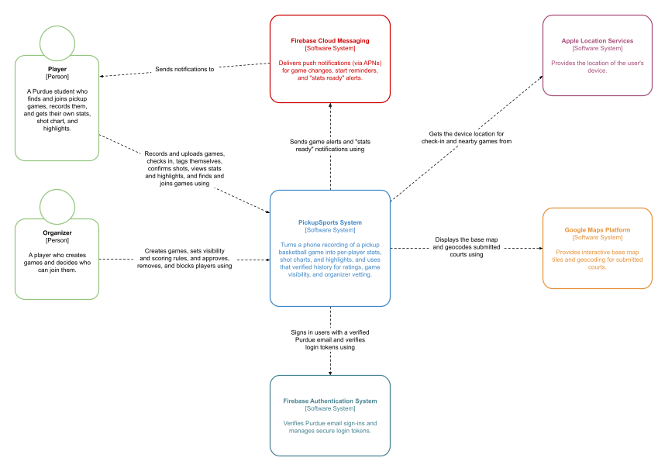Figure 1: System Context Diagram

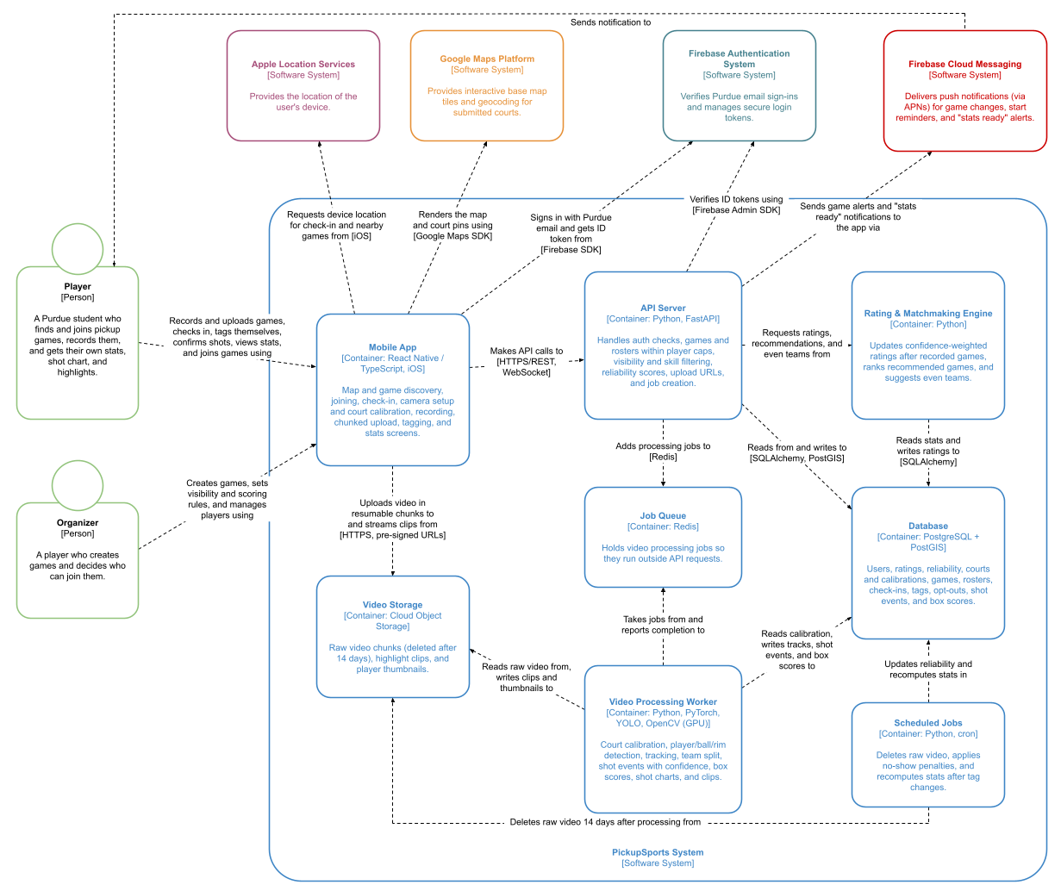
Figure 2: Container Diagram

Technology Stack

Languages
Python
Python will be used for backend development, computer vision processing, and the skill-based matchmaking algorithm. It will support player detection, multi-object tracking, shot recognition, video analysis, and player rating calculations.
TypeScript / JavaScript
TypeScript will be used for frontend development with React Native. It will support interactive UI components, camera recording workflows, player statistics dashboards, shot charts, map interactions, and communication with backend APIs.
SQL
SQL will be used to manage structured application data, including user profiles, game information, court locations, player rosters, skill ratings, recorded statistics, and video processing results.

Frameworks
React Native
React Native will be used to develop the PickupSports mobile application for iOS. It will support game discovery, video recording, camera setup, player identification, and viewing automatically generated statistics and highlights.
FastAPI
FastAPI will serve as the primary Python backend framework. It will provide RESTful endpoints for managing games, processing video uploads, retrieving player statistics, and communicating with the matchmaking and computer vision systems.
PyTorch
PyTorch will be used to train and run deep learning models for basketball video analysis. It will support fine-tuning object detection models using footage collected and labeled by the team.

Libraries
Ultralytics YOLO
YOLO-based object detection will identify basketball players, the ball, and the rim in recorded video frames. The detection model will be fine-tuned on labeled pickup basketball footage to improve performance under different lighting conditions and camera angles.
OpenCV
OpenCV will support video frame processing, court calibration, and geometric analysis. It will be used to calculate homographies that map player positions from camera footage onto a two-dimensional basketball court and help analyze ball trajectories.
Multi-Object Tracking (ByteTrack / BoT-SORT)
A multi-object tracking algorithm will associate player detections across video frames to maintain consistent player identities. Appearance-based features will help reconnect tracks when players overlap or temporarily disappear from view.
FFmpeg
FFmpeg will handle video processing operations such as extracting frames, compressing recordings, and generating highlight clips around detected made shots.
Google Maps SDK / Google Maps API
Google Maps will display nearby courts and available pickup games. It will support location-based discovery, court selection, and interactive map navigation.
SQLAlchemy
SQLAlchemy will serve as the Object Relational Mapper (ORM) between the Python backend and PostgreSQL database. It will simplify database operations involving players, games, statistics, and processing records.
Pydantic
Pydantic will validate and serialize API requests and responses, ensuring consistent communication between the mobile application, backend services, and video processing system.
WebSockets
WebSockets will support real-time updates for game availability, roster changes, and player counts without requiring users to manually refresh the application.

Database and Cloud Services
PostgreSQL
PostgreSQL will serve as the primary relational database for user accounts, player profiles, game schedules, skill ratings, recorded basketball statistics, video processing results, and participation history.
PostGIS
PostGIS will extend PostgreSQL with geographic capabilities, enabling nearby court searches, distance calculations, and location-based game recommendations.
Firebase Authentication
Firebase Authentication will manage user authentication and account verification. Users will register using verified Purdue email addresses.
Firebase Cloud Messaging (FCM)
Firebase Cloud Messaging will send push notifications about upcoming games, roster changes, invitations, and completed video analysis results.
Cloud Object Storage
Cloud object storage will store uploaded game recordings and generated highlight clips. Videos will be uploaded in resumable chunks, and raw recordings will be automatically deleted within 14 days after processing to meet privacy requirements.
Background Job Queue and GPU Workers
A background job queue will manage uploaded videos awaiting analysis. GPU-enabled workers will execute object detection, tracking, shot recognition, and highlight generation asynchronously without blocking regular backend requests.

Development Tools
GitHub Actions
GitHub Actions will automate testing and continuous integration. Workflows will validate application functionality, backend endpoints, and computer vision processing components.
GitHub Projects
GitHub Projects will be used for task management, milestone tracking, and collaboration between team members.
Swagger / OpenAPI Documentation
Swagger will provide documentation and interactive testing for FastAPI endpoints, improving coordination between mobile, backend, and computer vision development.
Postman
Postman will be used to test backend API endpoints, troubleshoot request and response handling, and verify communication between application components.
Video Annotation Tools
Video annotation tools will be used to label basketball footage collected by the team. Annotated frames will provide training and evaluation data for player, ball, and rim detection models.

Summary of Technology Choices
PickupSports combines a React Native mobile application, FastAPI backend, PostgreSQL/PostGIS database, and Python-based computer vision pipeline. PyTorch, YOLO, OpenCV, and multi-object tracking algorithms will process basketball recordings to generate per-player statistics, shot charts, and highlights. Cloud storage and GPU workers will support asynchronous video processing, while Firebase and Google Maps will provide authentication, notifications, and game discovery. Together, these technologies enable PickupSports to connect automated basketball performance analysis with skill-based matchmaking and pickup game coordination.

GenAI Statement
Generative AI was utilized to refine the problem and solution descriptions for clarity and tone, as well as to assist in identifying credible sources and formatting their corresponding citations. AI also clarified competitive and stakeholder analysis summaries. Additionally, AI was utilized to provide a rough draft of the C4 model diagrams, however, the final draft was created by hand in Google Drawings. AI was also used to improve the flow of the System Design description.

Citations
[1] Purdue University RecWell. “Intramural Sports.” https://www.purdue.edu/recwell/sports-and-programs/intramural
[2] Sports & Fitness Industry Association. “Participation Hits New High, but Majority of Americans Not Yet Meeting Recommended Guidelines of Weekly Activity, SFIA’s 2026 Topline Report Finds,” March 12, 2026. https://sfia.org/resources/participation-hits-new-high-but-majority-of-americans-not-yet-meeting-recommended-guidelines-of-150-minutes-of-weekly-activity-sfias-2026-topline-report-finds/
[3] Soria, K. M., Boettcher, B., and Hallahan, K. “The Effects of Participation in Recreational Activities on Students’ Resilience and Sense of Belonging.” Recreational Sports Journal, 46(2), 184-192, 2022. https://doi.org/10.1177/15588661221125201
[4] NEX Team. “HomeCourt: Basketball Training.” Apple App Store. https://apps.apple.com/us/app/homecourt-basketball-training/id1258520424
[5] Veo. “Veo Cam Subscriptions.” https://us.shop.veo.co/
[6] Cui, Y., Zeng, C., Zhao, X., Yang, Y., Wu, G., and Wang, L. “SportsMOT: A Large Multi-Object Tracking Dataset in Multiple Sports Scenes.” Proceedings of the IEEE/CVF International Conference on Computer Vision (ICCV), pp. 9921-9931, 2023. https://arxiv.org/abs/2304.05170

